首先在工具箱中加载Emgu.CV.UI.dll，添加其中包含的几个控件，

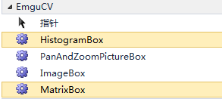

选择其中的ImageBox添加到界面上，并添加如下代码

private void button1_Click(object sender, EventArgs e)

{

using (Mat img = new Mat(200, 400, DepthType.Cv8U, 3))

{

img.SetTo(new Bgr(255, 0, 0).MCvScalar); // set it to Blue color

//Draw "Hello, world." on the image using the specific font

CvInvoke.PutText(

img,

"Hello, world",

new System.Drawing.Point(10, 80),

FontFace.HersheyComplex,

1.0,

new Bgr(0, 255, 0).MCvScalar);

//Show the image using ImageViewer from Emgu.CV.UI

//ImageViewer.Show (img, "Test Window");

imageBox1.Image = img;

}

}

结果如下图所示：

